**Computer Network**:

A computer network is an interconnection of multiple devices also known as hosts, that are connected using different paths for the purpose of sending or receiving data or media. Computer network also help in communication between two devices that are known as network devices.

**Transmission medium**:

A transmission medium is a physical path by which a message travels from sender to receiver. Some examples of transmission medium are twisted pair wire, coaxial cable, fiber optical and radio waves.

**Protocol**:

A protocol is a set of rules that governs the data communication. It represents the arrangement between two communicating devices. With out a protocol two devices may be connected but not be communicating.

**Direction of data flow**:

**Simplex:** In simplex mode the communication is unidirectional

Example**:** keyboard, monitor.

**Half-duplex**: In half duplex mode each station can both transmit and receive data but not at the same time. When one device is sending the other can only receive and vice versa.

Examples walkie-talkie, radios.

**Full duplex**: In full duplex mode, both stations can send and receive data at the same time.

Example: telecommunication.

**Network**:

A network is a set of devices connected by communication links.

A link is a communication pathway that transfers data from one device to another device.

**Type of connections**:

Two devices must be connected in some way to the same link at the same time for transmitting of data. There are two possible ways to this

1. Point to point communication
2. Multipoint communication

**Point to point communication:**

A point-to-point communication provides a direct link between to devices**.**

**Multi point communication:**

A multi-point communication is more than 2 specific devices are connected to a single link.

**Topologie**s:The term tropology is used to refer to the way in which a network is connected physically.

There are basically four types of topologies.

1. Bus
2. Ring
3. Star
4. Mesh

**Bus topology**: In bus topologyone cable is connected to all the devices. Here the cable acts as a backbone to the link. 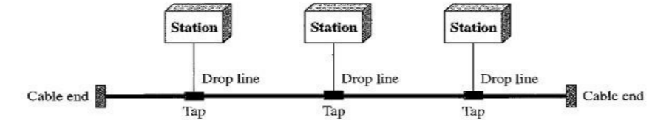

**Ring topology:** In a ring topology the devices are connected with point-to-point communication with the two devices on either side.

The signal passes along the ring in one direction until it reaches its receiver.

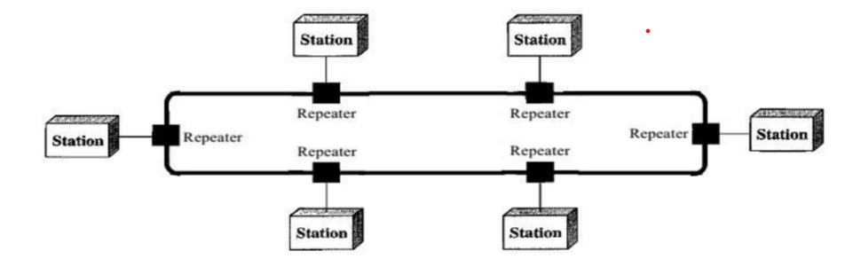

**Star topology:** In star topology each device is connected by point to point to a central control called as hub. The devices are not connected to one another. A star topology does not allow direct traffic between devices

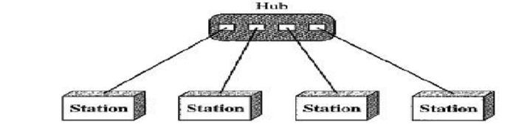

**Mesh topology:** In a mesh topology each device has a dedicated point to point link to every other device. The link carries the traffic only between those two devices.

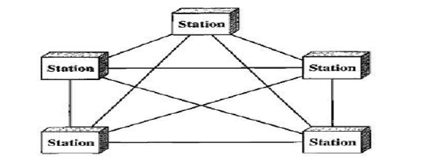

**Classifications of network:** There are 3 categories of network depending on its size.

1. **LAN (local area network)**
2. **WAN (wide area network)**
3. **MAN (metropolitan area network)**

**Local area network:** A LAN provides short distance transmission of data over small geographical area. Exp single office, campus, or building.

LAN size is limited to few kilometers.

LAN is generally privately owned

**Wide area network:** A WAN provides long distance transmission of data over a long geographical area. EXP A country

**Metropolitan area network:** A MAN is a network with a size between LAN and WAN. It is designed for customers with high-speed connectivity.

**PROTOCOLS:** A protocols is a set of rules that govern data communication. A protocol is defining what is communicated, how is communicated, and when it is communicated. For communication to occur, the entity must agree on the protocols.

The three elements of protocol are

1. Syntax: the structure or the format of data.
2. Semantics: refers to the meaning of the bits
3. Timing: refers to when and how fast they Can be sent.

**STANDARDS:** Standards provide the guidelines to the manufactures, vendors, and government agencies and other service provider to ensure the type of connectivity required in today’s market place and in international communications.

1. **ISO**
2. **IEEE**
3. **ANSI**
4. **ITU-T**
5. **EIA**

**OSI model:**

open system interconnection. It is developed by iso (International organization for standardization).

It is a seven-layer architecture where each layer has a specific function.

**The seven layers of OSI model are**

1. **Physical layer**
2. **Data link layer**
3. **Network layer**
4. **Transport layer**
5. **Session layer**
6. **Presentation layer**

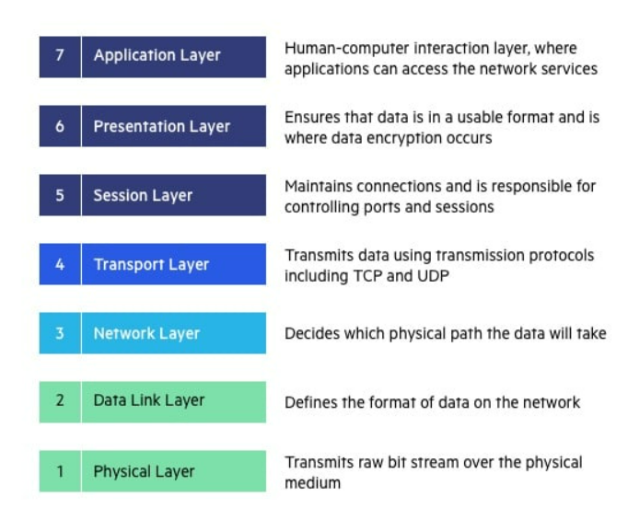

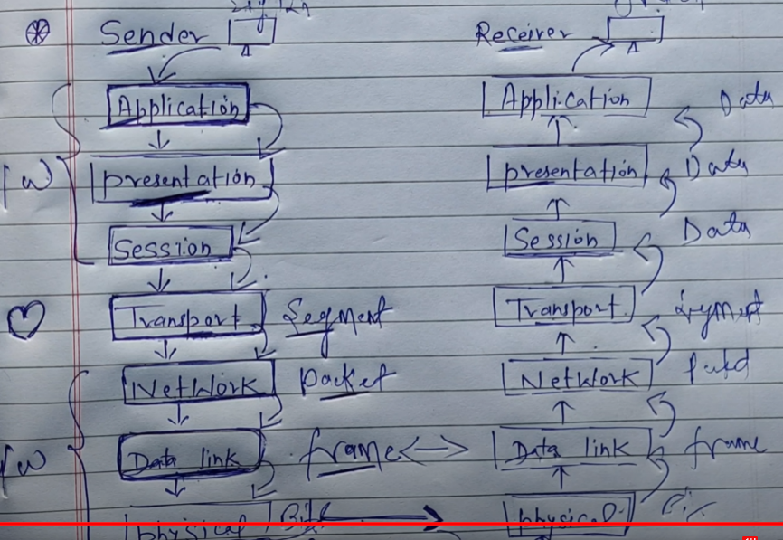

**The OSI model helps users and operators of computer networks:**

* Determine the required hardware and software to build their network.
* Understand and communicate the process followed by components communicating across a network.
* Perform troubleshooting, by identifying which network layer is causing an issue and focusing efforts on that layer.

**IP address:** INTERNET PROTOCOL ADDRESS

An Ip address is a unique number provided to each and every device. It is in the form of integer number separated by dot.

**Types of Ip address**:

**Ipv4 Ipv6**

**Length 32 bits length 128 bits**

**Octet 4 octet 8**

**Range 0-255 range 255-FFFF (65535)**

**4 billion 340 trillion**

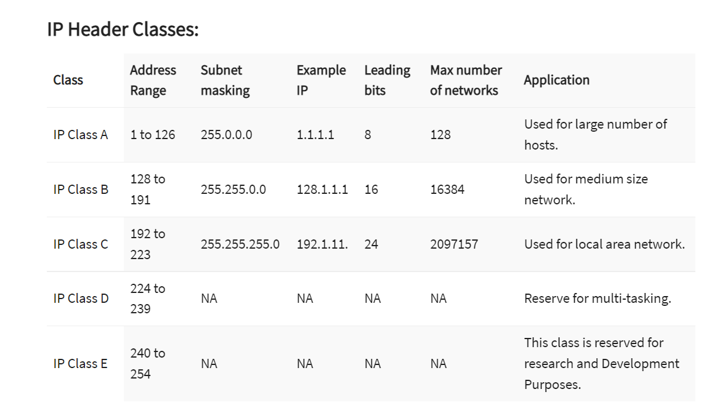

**Subnetting:**

A subnetting or a subnet is a logical division of Ip address. The practice of division of a network into one or more network is called subnetting.

**Gateway:**

A gateway is a hardware device that is used to connect two dissimilar networks. It allows as to send or receive data through network even if it is connected to a LAN

**Advantages:**

1. It operates all the 7 layers of protocol.
2. We cannot access the internet without gateway

**Disadvantages:**

1. It is more expensive.
2. The data transfer rate is slow.

**Hub:**

Hub is a hardware device which is used to connect multiple computers in a network. All the information send to the hub is automatically sent to the port to each device. Hub is generally used to connect computers in a LAN

**Advantages:**

1. The hub can transmit message.
2. It is less expensive.
3. Easy installation.

**Disadvantages:**

1. If the hub fails the entire network will fail.
2. Hub does not provide any security.

**Router:** A router is a network device which works as traffic control. The main work of a router is to find the congestion free path trough which the data is transmitted.

**Ipv6:**

1. 128 bits long
2. 8 sections called hextet
3. Uses: to separate hextet
4. It uses hexadecimal (0-9) or (a-f)